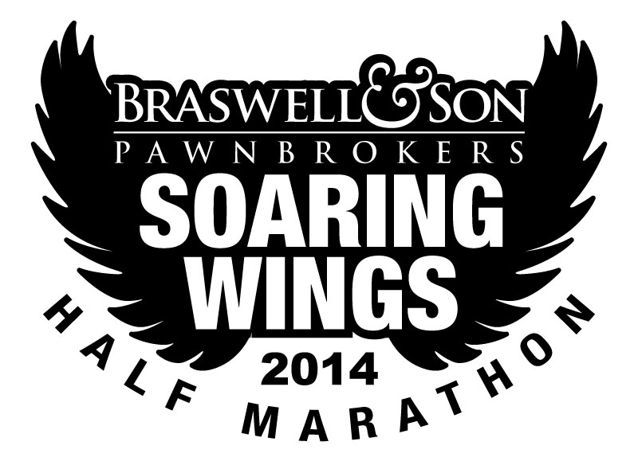
PERMISSION FOR BIB TO BE PICKED UP BY ANOTHER PERSON

I give my friend, _____________________________________________________, permission to pick up my Soaring Wings Half or Relay bib and shirt for me. I also understand that he/she must have a copy of my driver’s license, and that he/she must also show their driver’s license.

Signature of Bib Owner

Date

